1. Write a shell script to get the current date, time, username and current working directory.

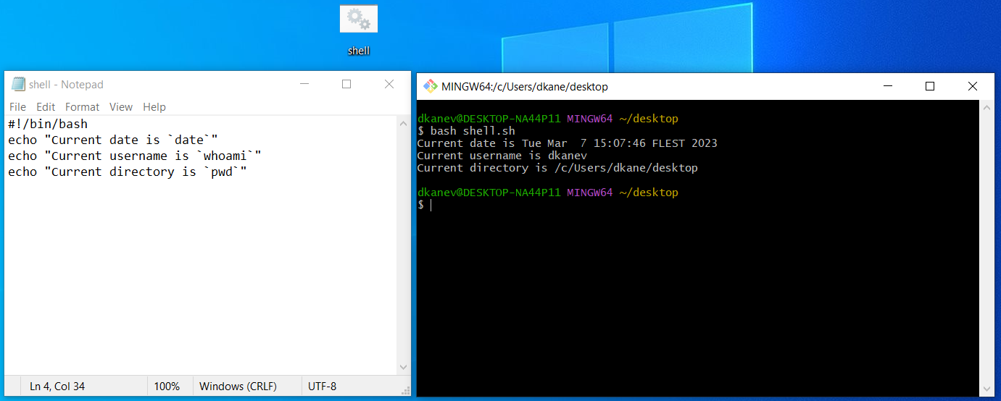

Here the example with username can be replaced with `id` so a bit more information can be displayed:

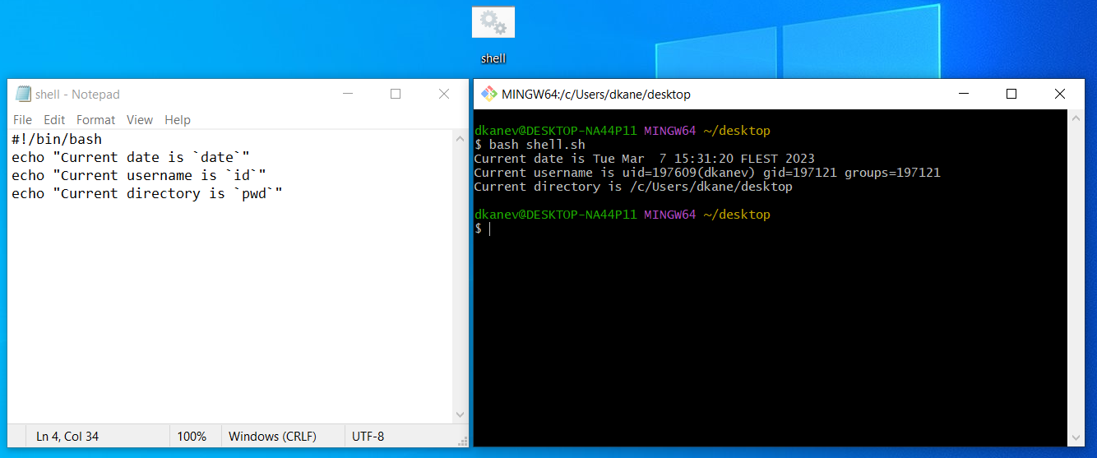

1. Write a shell script that prints “I love learning about DevOps” on the screen. Message should be a variable.

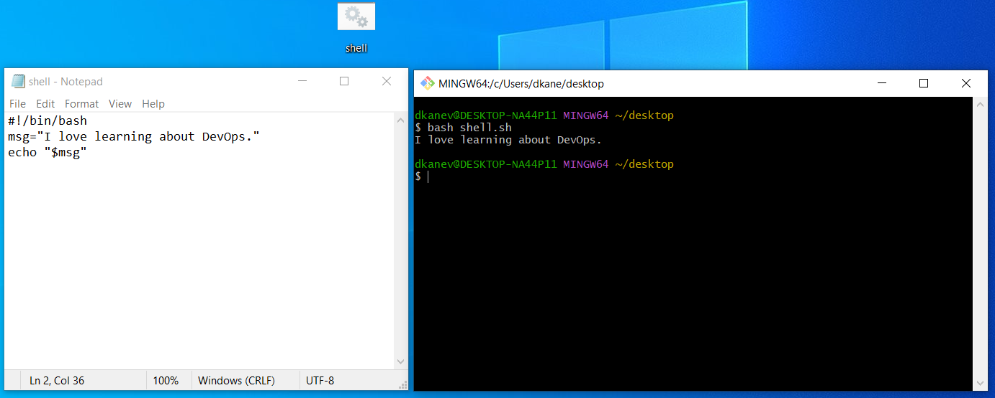

1. Write a shell script that displays “plan code build test release deploy” on the screen with each appearing on a separate line.

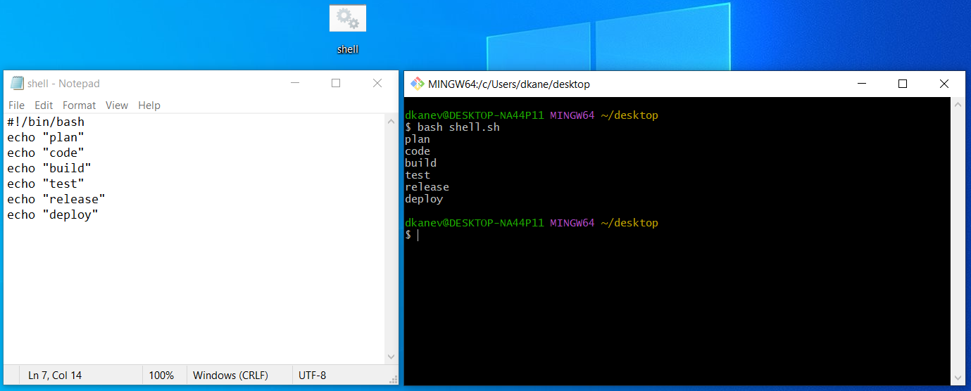

1. Write a shell script that prompts the user for a name of a file or directory and reports if it is a regular file, a directory, or another type of file. Also perform a ls command against the file or directory with the long listing option.

* **Here my code did not work. I will check the lab examples and update the file afterwards.**

1. Use arguments in a script. Total number of arguments should be three.

We check the total number of arguments:

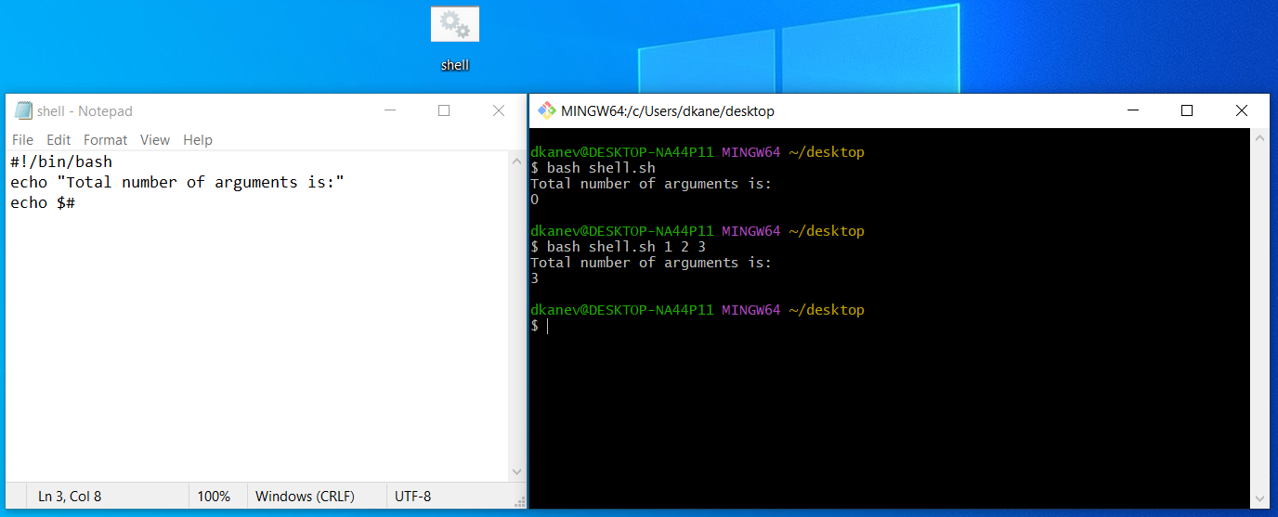

Below we make a check if there are less or more:

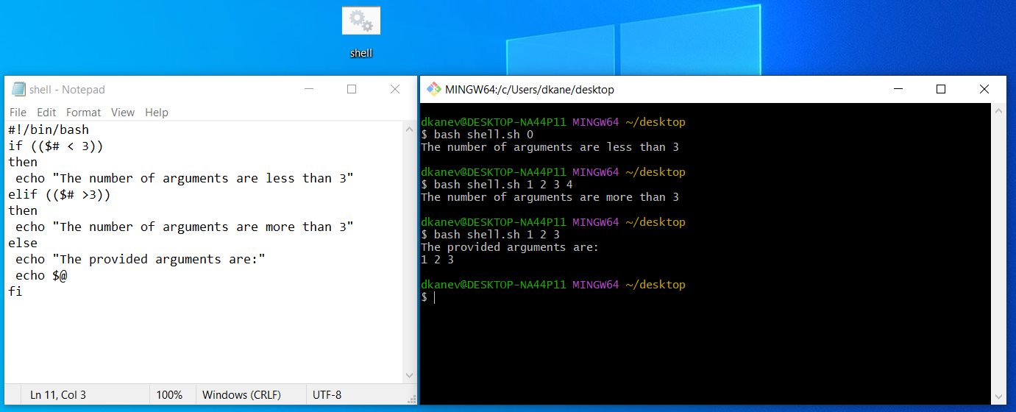

1. Write a script that till output your name out of a variable and will display the server uptime.

First, I used a different command:

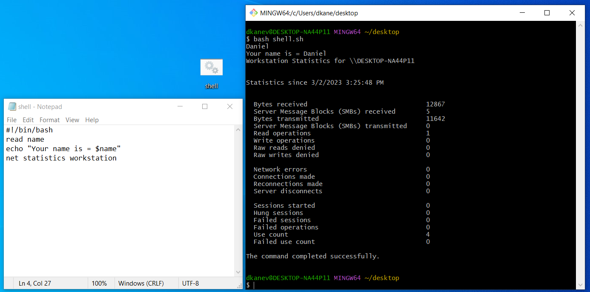

And in the virtual machine, I used the uptime command:

